Online

Shopping

System

Submitted by:

* Agila A
* Anusuya V
* Deepika A
* Abinaya S

RMK Engineering College

SOFTWARE DEVOLPMENT PRACTISES

**Table of contents:**

Introduction:

1. Users of the system
2. Definition & acronym
3. Technologies to be used
4. References

Overall description:

1. Operating environment
2. Project objectives
3. System features

Requirements:

1. Functional requirements
2. Non-functional requirements

System tools:

1. Front end
2. Backend:
3. Model layer
4. Controller layer

1.INTRODUCTION

This project is a web-based shopping system for an existing shop. Online shopping is the process where consumers directly buy goods or services from a seller in real-time, without an intermediary service, over the Internet. It is a form of electronic commerce. This project is an attempt to provide the advantages of online shopping to customers of a real shop. It helps buying the products in the shop anywhere through internet by using an android device. Thus, the customer will get the service of online shopping and home delivery from his favourite shop.

* 1. USER OF THE SYSTEM

The system after careful analysis has been identified to be presented with the following modules and roles. The modules involved are:

1. USERS
2. MODERATOR
3. ADMINISTRATOR
   * 1. USERS

A new user will have to register in the system by providing essential details in order to view the products in the system. The admin must accept a new user by unblocking him.

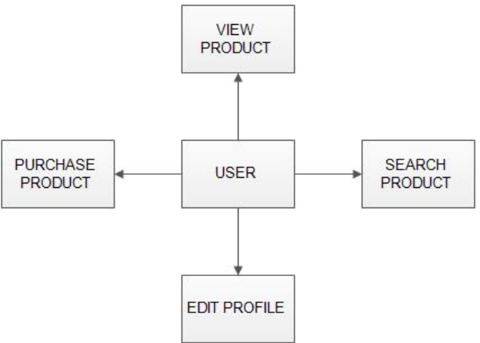

* + 1. MODERATOR

A moderator is considered as a staff who can manage orders for the time being. As a future update moderator may give facility to add and manage his own products. Moderators can reduce the work load of admin. Now moderator has all the privilege an admin having except managing other moderators. He can add products and users. He can also check the orders and edit his profile.

1. Manage products
2. Manage users
3. Manage orders
   * 1. ADMINISTRATOR

The administrator is the super user of this application. Only admin have access into this admin page. Admin may be the owner of the shop or the one running it. The administrator has all the information about all the users and about all products. This module is divided into different sub-modules.

1. Manage Moderators
2. Manage Products
3. Manage Users
4. Manage Order

1.2 DEFINITION AND ACRONYMS

developers of the site, testers, website owners,

managers and coordain

* 1. OSS-Online shopping System (for electronics item shop)
  2. SRS- Software Requirement Specification
  3. GUI- Graphical User Interface
  4. Stack holder- The person who will participate in system

Ex. Customer, Administrator, Visitor etc

1.3 TECHNOLOGIES TO BE USED

JSP (Java Server Pages), HTML (Hyper Text Markup Language), CSS (Cascading Style Sheets), JAVA SCRIPT, ANDROID are utilized to implement the frontend.

2.OVERALL DESCRIPTION

The Online Shopping system (OSS) application enables vendors to set up online shops, customers to browse through the shops, and a system administrator to approve and reject requests for new shops and maintain lists of shop categories. Also, the developer is designing an online shopping site to manage the items in the shop and also help customers to purchase them online without visiting the shop physically. The online shopping system will use the internet as the sole method for selling goods to its consumers.

2.1 OPERATING ENVIRONMENT

The OS is a website that shall operate in all famous browsers, for a model we are taking Microsoft Internet Explorer versions 7.0, 8.0, and 9.0.

2.2 PROJECT OBJECTIVES

The objective of the project is to make an application in android platform to purchase items in an existing shop. In order to build such an application complete web support, need to be provided. A complete and efficient web application which can provide the online shopping experience is the basic objective of the project. The web application can be implemented in the form of an android application with web view.

* 1. SYSTEM FEATURES

1. Product Reviews
2. Special Offers and Discounts
3. User-Friendly Navigation
4. Wishlist
5. Product Filtering and Softening

REQUIREMENTS:

1. Functional requirements:
   1. Login

This feature is used by the user to login into the system. A user must login with his user’s name and password to the system after registration. If they are invalid, the user will not be allowed to enter the system.

Id’s

Email

Password

Forgetpassword

Signup button

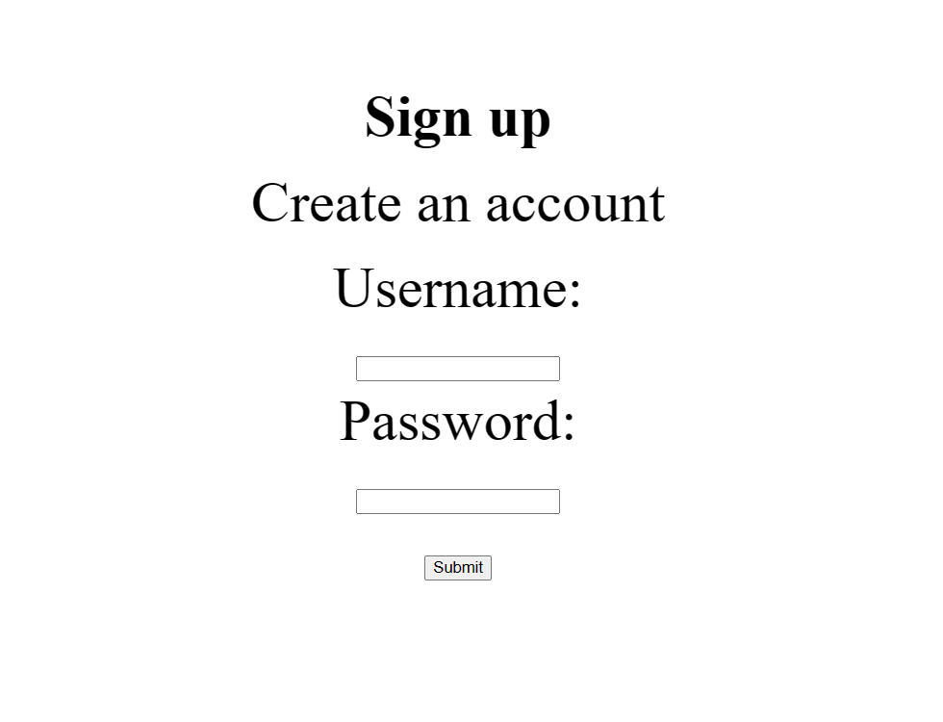

* 1. Registration

New user must register in order to access the features in the application. Once registered they can log in anytime to access the application.

* 1. Dashboard

A homepage which contains all the details regarding the clothing, footwear and accessories for men, women and kids

Id’s

userNavbar

Mensection

Womensection

Kidssection

* 1. Cart

Items that are selected by the customers to buy can be added to the cart for further making the payments.

* 1. Payment

In this system we are dealing the mode of payment by Cash on delivery. We can extend this to credit card, debit card etc in the future.

1. Non-functional requirements:
2. Performance

* Peak Load performance
* eCommerce -< 3 sec
* Admin application < 2 sec
* Non-Peak Load Performance
* eCommerce <2 sec
* Admin Applications < 2 sec

1. Browser capability

All latest browsers

1. Security

App Platform – Username / Password – Based Credentials. Sensitive data has to be categorized and stored in a secure manner. Secure connections for transmissions of any data

1. Cloud

The Solutions should be made Cloud-ready and should have a minimum impact when moving away to Cloud infrastructure

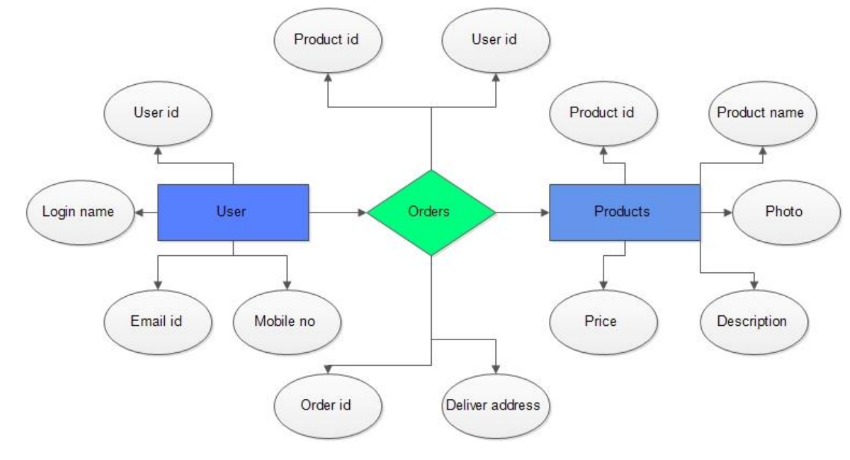FRONTEND

User:

1. Auth: The user can authenticate login and signup credential.

2. Register: The new user has options to sign up by providing their basic details.

ids:

∙ Email

∙ Username

∙ Password

∙ Re-typepassword

∙ RegisterButton

∙ SigninLink

∙ RegisterBox

3. Login: The existing user can log in using the registered email id and password.

Ids:

∙ Email

∙ Password

∙ LoginBox

4. Dashboard: A homepage which contains all the details regarding Men’s section, Women’s section, Kids section of Online shopping

Ids:

1. userNavbar

2. Men’s section

3. Women’s section

4. Kids section

5. logoutButton

Admin:

Admin Dashboard: a dashboard where the list of online product pricing, plans ensuring that price changes are implemented in an accurate and timely manner is displayed on the admin side.

Moderator:

Moderator Dashboard: a dashboard to ensure the protection of platform users, safeguard the reputation of digital brands and guarantee compliance with applicable regulation is displayed on the moderator side

BACKEND:

Model Layer:

1. User Model: the user type (admin or customer) and all user information are stored

a. Attributes:

i. email: String

ii. password: String

iii. username: String

iv. mobileNumber: String

v. active: Boolean

vi. role: String

1. Login Model: This class contains the email and password of the user.

a. Attributes:

i. email: String

ii. password: String

1. Men’s section Model: This contains the things needed for a man.

a. Attributes:

I. All Clothes: Character

ii. Casual and formal Foot wear: Character

iii. Accessories: Character

iv. Beauty: Character

1. Women section Model: This contains the things needed for a woman.

a. Attributes:

i. All Clothes: Character

ii. Casual and formal Foot wear: Character

iii. Accessories: Character

iv. Beauty: Character

1. Kids section Model: This contains the things needed for a kid.

a. Attributes:

I. Boys Clothes: Character

ii. Girls clothes: Character

iii. Foot wear: Character

iv. Baby Clothing: Character

Controller Layer:

1. Signup Controller: This class control the user signup

a. Methods:

i. saveUser (UserModel user): This method helps to store users in the database and return true or false based on the database transaction

1. Login Controller: This class controls the user login.

a. Methods:

i. checkUser (LoginModel data): This method helps the user to sign up for the application and must return true or false.